Social Distancing

1. Control the spread of contagious diseases
2. Distance Themselves from one another, reducing close contact

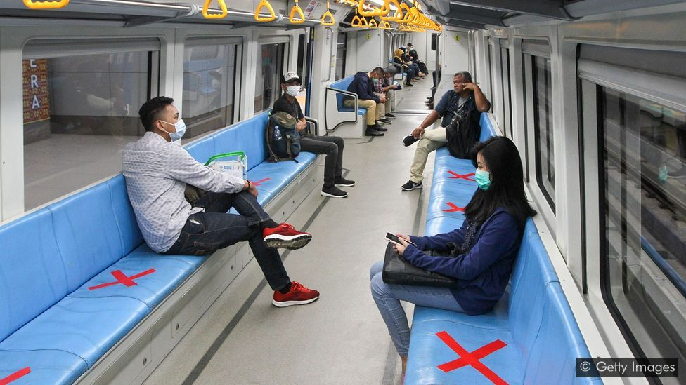

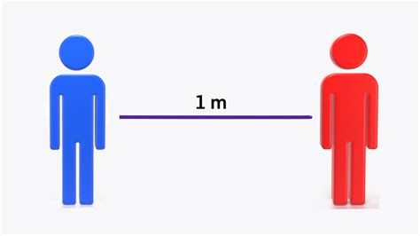

IMPLEMENTING THE SOCIAL DISTANCING

**1} Open CV**

-Used for computer vision

-Image and Videos

-Python, C++, Java

-Windows, Linux, Mac

**2) Deep Learning**

-Technique which mimics the human brain

-Neural Network

How we will use it?

-Input video

-Train the model

-Detect the Object

-Calculate Distance

-Validate and Present

Software and Packages

ANACONDA - WEB CAM

PYCHARM - OPEN CV

VISUAL STUDIO - NUMPY

PAN DAS - IMUTILS

ARGPARSE

5.

CONCLUSION

6.

FUTURE SCOPE



 

 

**TIPS FOR STAYING CONNECTED WHILE SOCIAL DISTANCING**

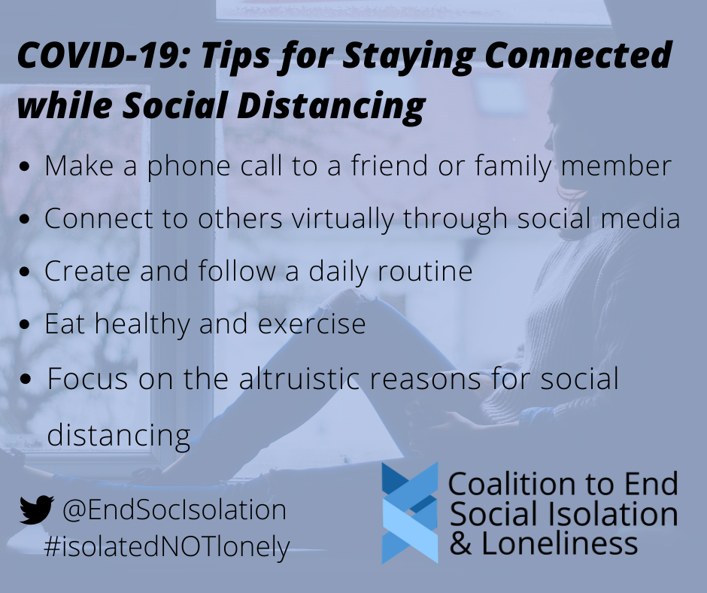

**RESULTS OF SOCIAL DISTANCING BE LIKE**

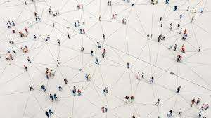

**(CODE) OUTPUTS:-**



